Create a custom image

It can be done with dockerfile

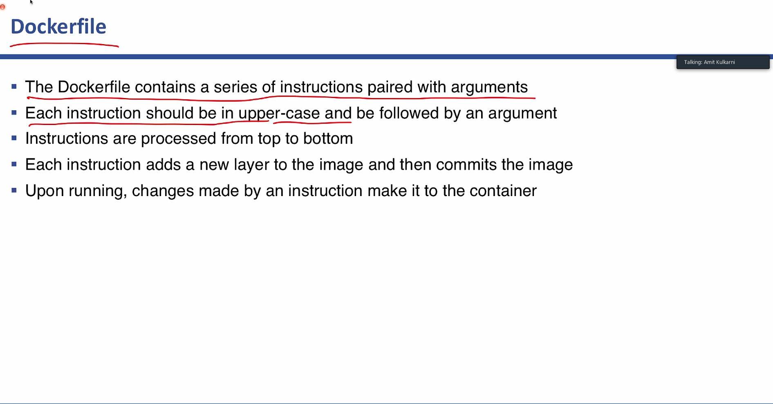

Docker file action strings can be used todo it.

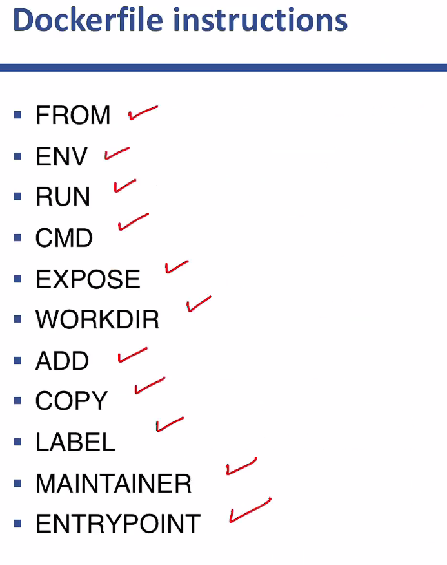

docker image build -t mywebsite .

-In the docker file folder type this command to build the file.

docker container run -itd -p 8080:80 --name mywebsite mywebsite

-Create a container and run with the local host

docker image push pythoncpp/mywebsite

